Real Estate Sales

By Gerard Utoware

Overview

Overviews – Page 3

Q1 – Page 4

Q2 – Page 7

Q3 – Page 9

Further Data – Page 11

Overview of the tool used

The main advantage of python in comparison to other data analytic tools such as excel, would be Python’s ability to handle large volumes of data without hindering productivity. Running scripts using the libraries on allows for more automation and ease of obtaining analysed data. With this task, the data was imported from python which ensures that data will not be lost or tampered with while performing data analysis. After defining the columns from the imported data, it was less tedious to run scripts than to perform individual analysis on excel.

Overview of the libraries used

Numpy, pandas and matplotlib were used in the script. All three python libraries allow different functions to be performed. Pandas allows data analysis scripts to be conducted on python. It utilises two other libraries, being numpy and matplotlib. Matplotlib allows for data visualisation through a variety of charts such as bar and pie charts. Numpy permits mathematical operations in python. The combination of these three libraries is what allowed the following data and charts to be formed and analysed.

Overview of the dataset

Overall, the data suggests that the 4th Quarter of 2019 was the most profitable for Real Estate. There were several quarters in the data set that were relatively close to each other such as the 4th Quarter of 2018 as well as the 1st and 3rd Quarters of 2019. 2019 was the most profitable year of 2019. Sales in 2018 did not start well, 3rd Quarter 2018 was the first quarter of notable sales. On the other hand, the sales after the 4th Quarter 2019 dipped drastically to levels below the end of 2018. The 24th May 2019 was the single largest day of sales.

Q1

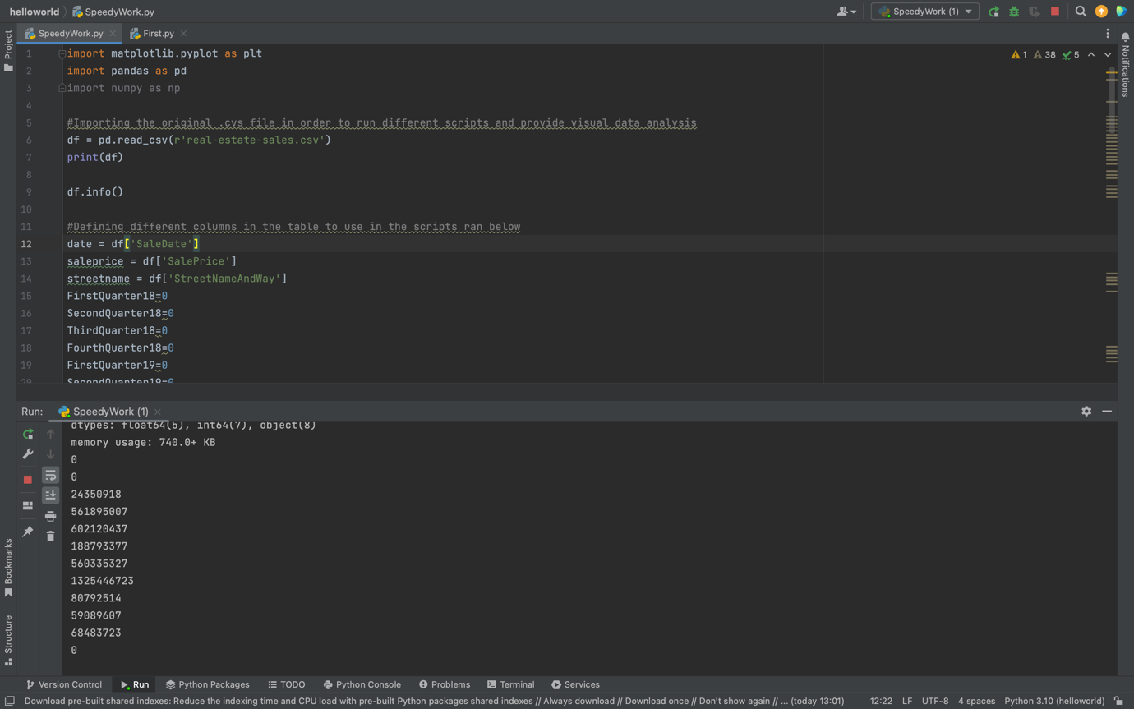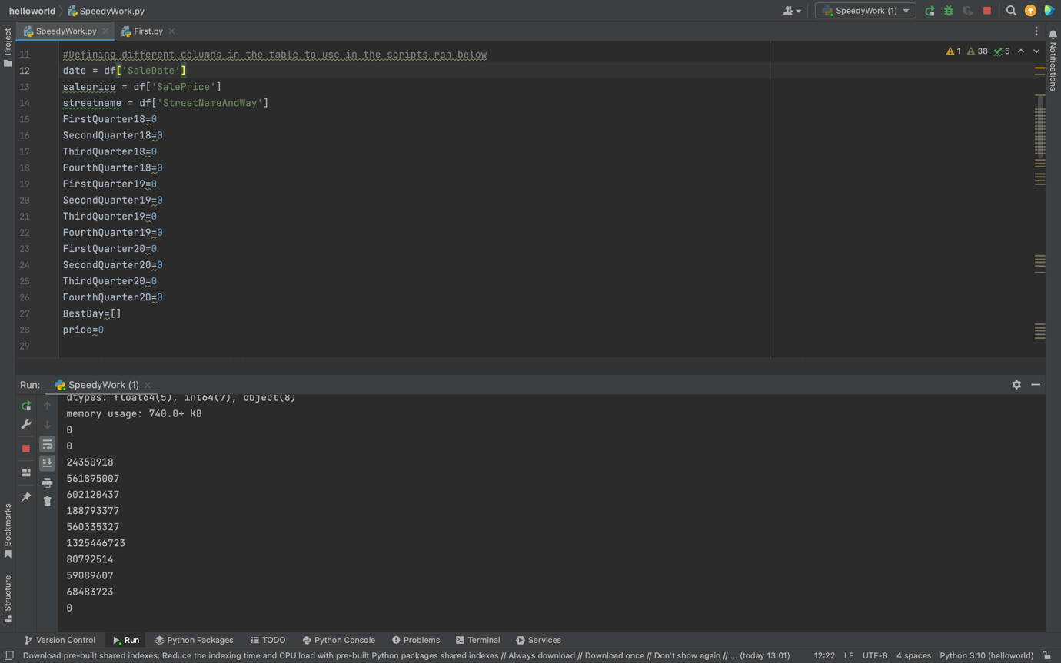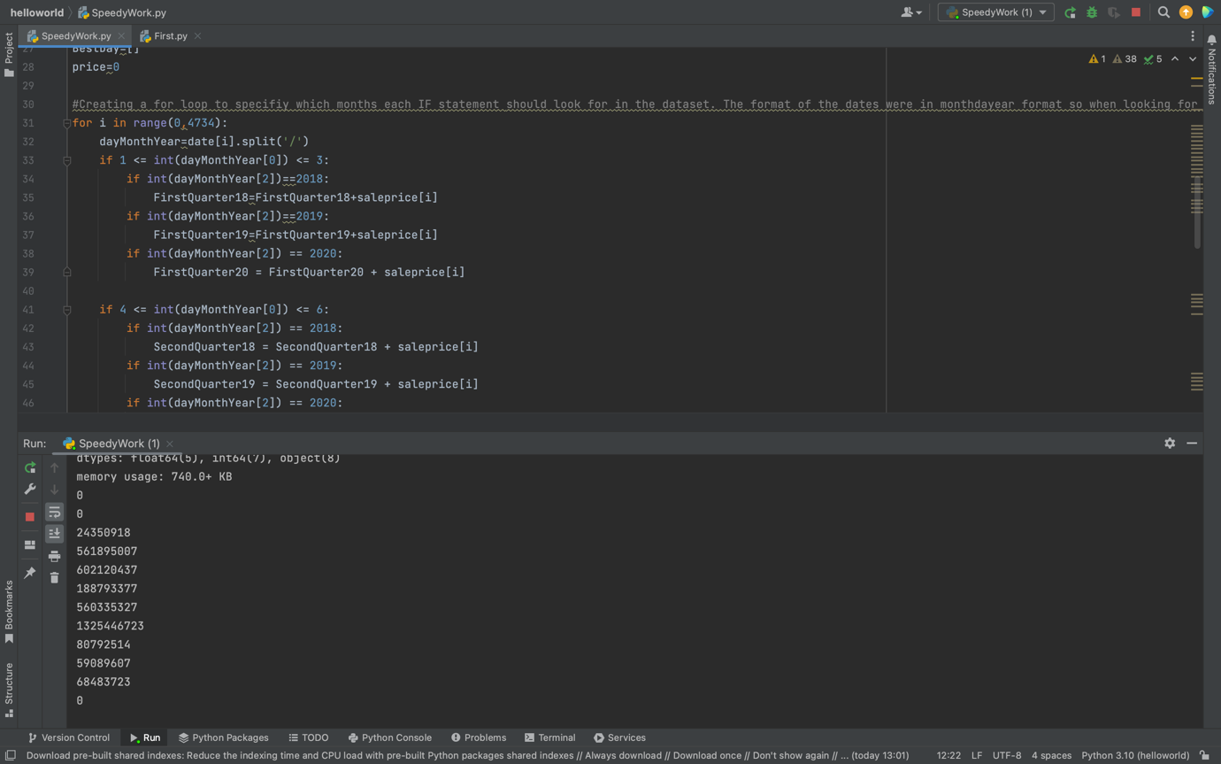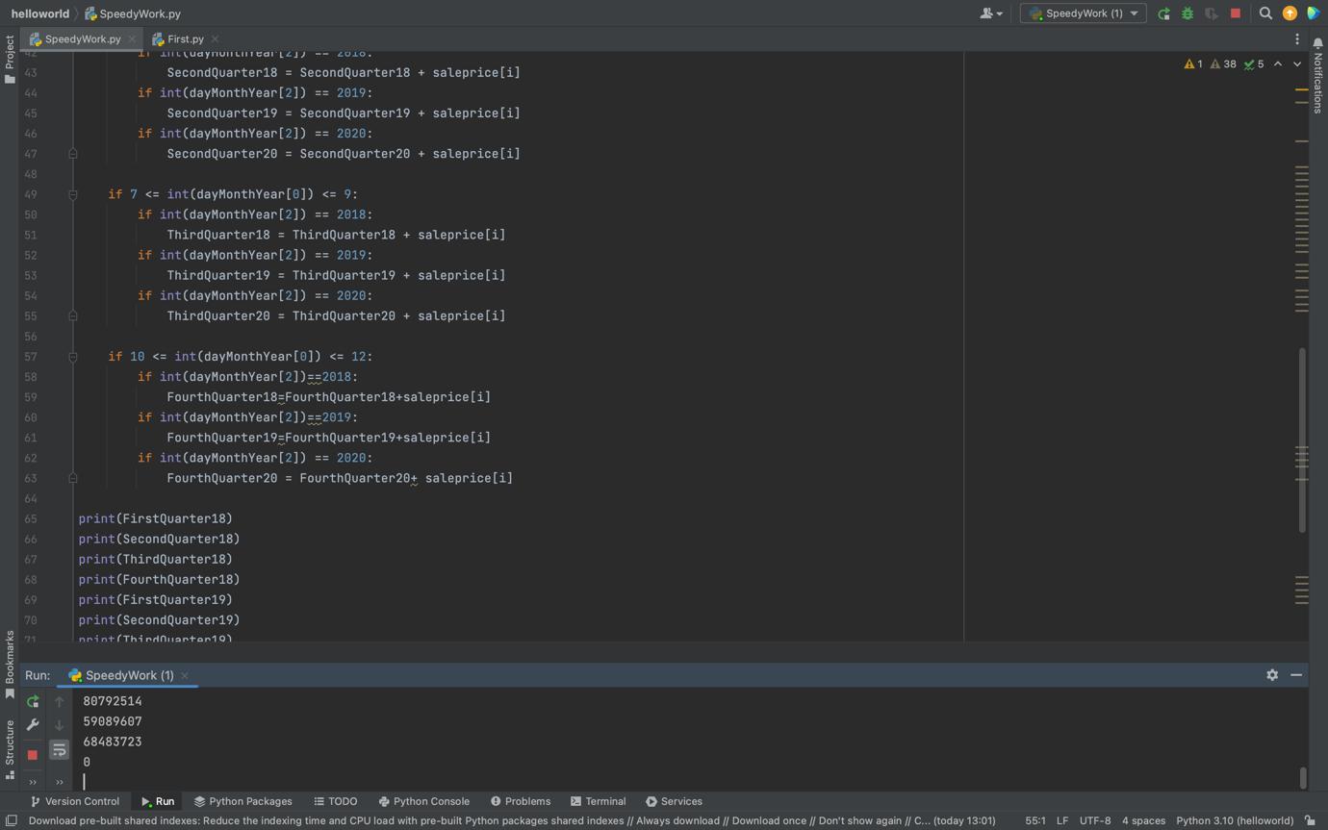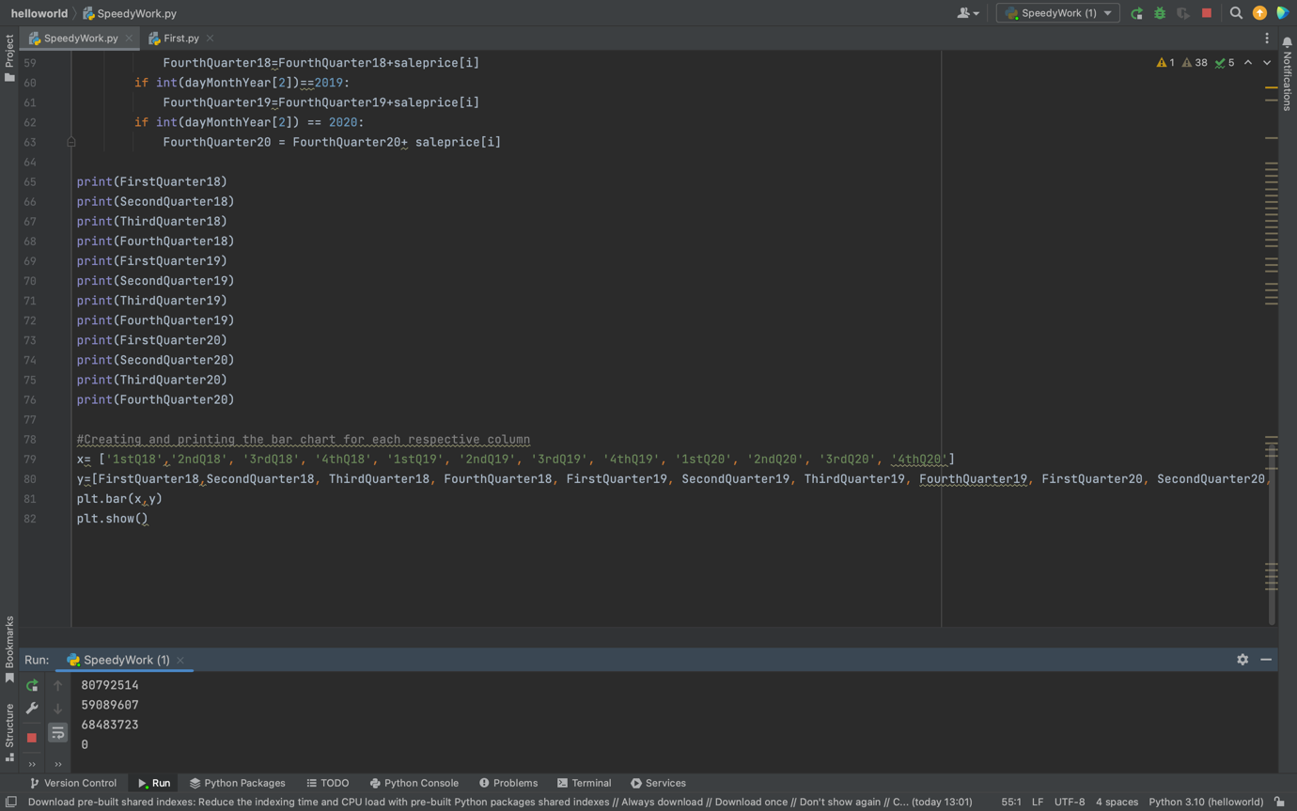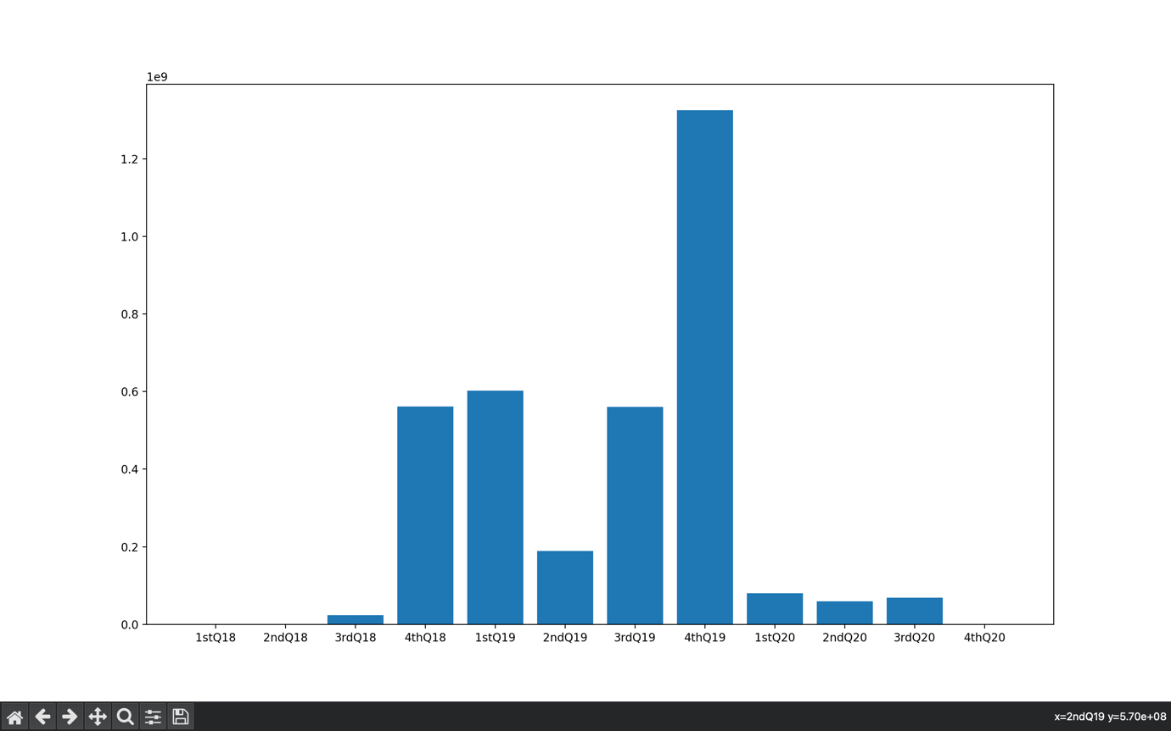

Out of all quarters in the 3 year period given, the 4th quarter of 2019 has by far the largest total sales. The first half of 2018 did not have any sales to represent on this graph.

Q2

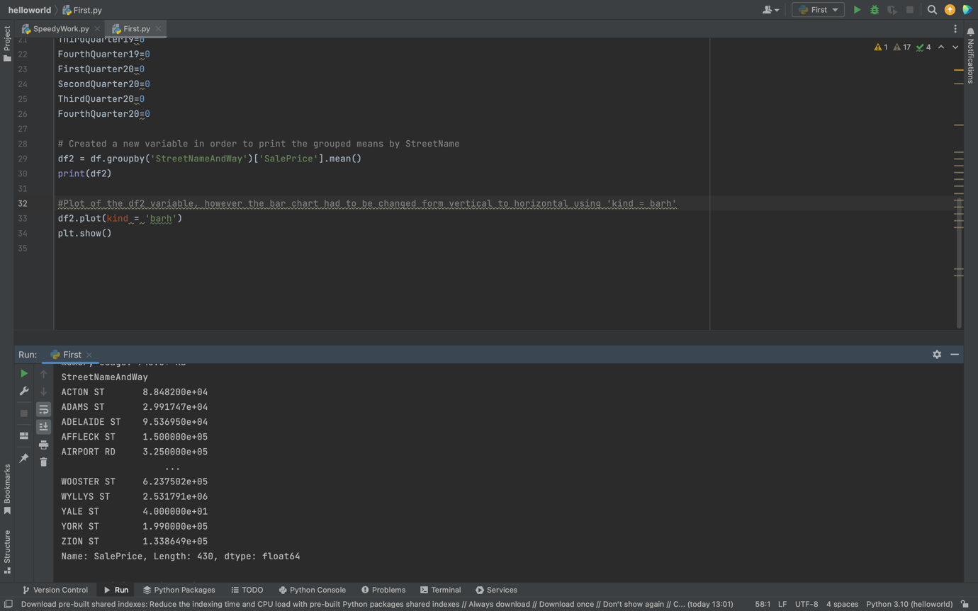

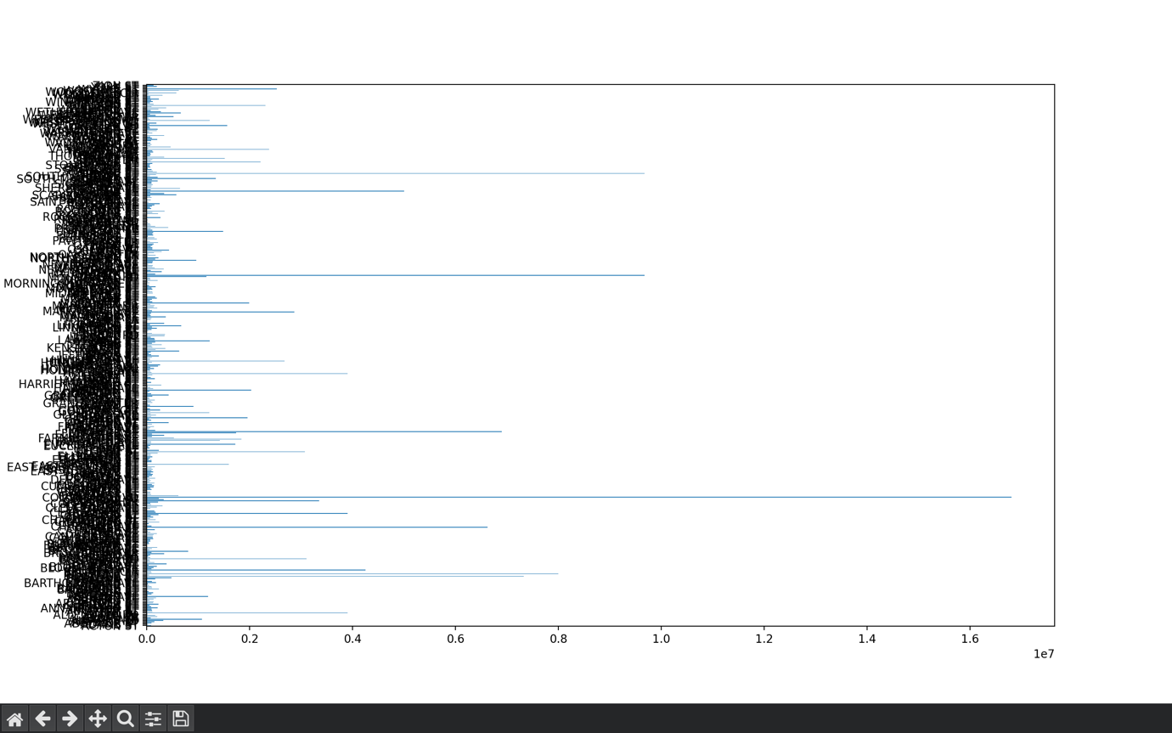

This vertical bar graph depicts the 430 unique areas in the real estate.

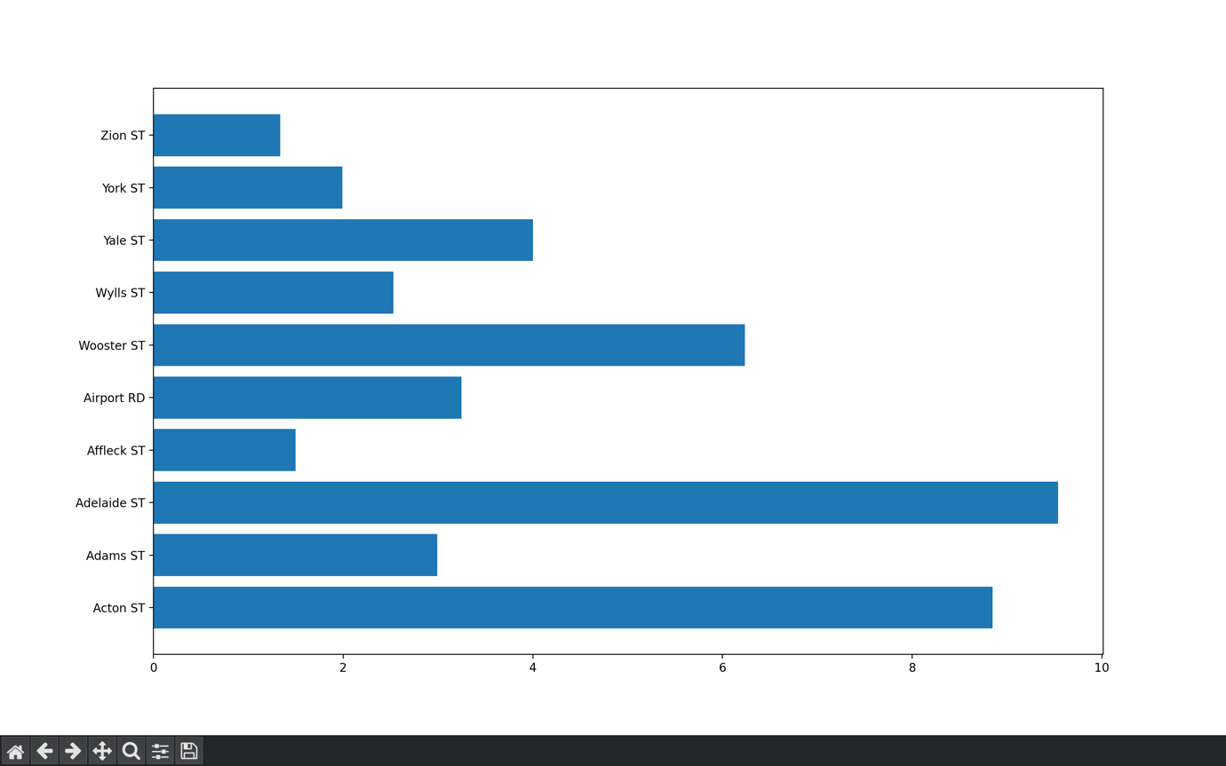

This is an alternative vertical bar graph displaying the first 5 and last 5 areas in a clearer graph. Here, Adelaide and Acton ST have the highest average sale price.

Q3

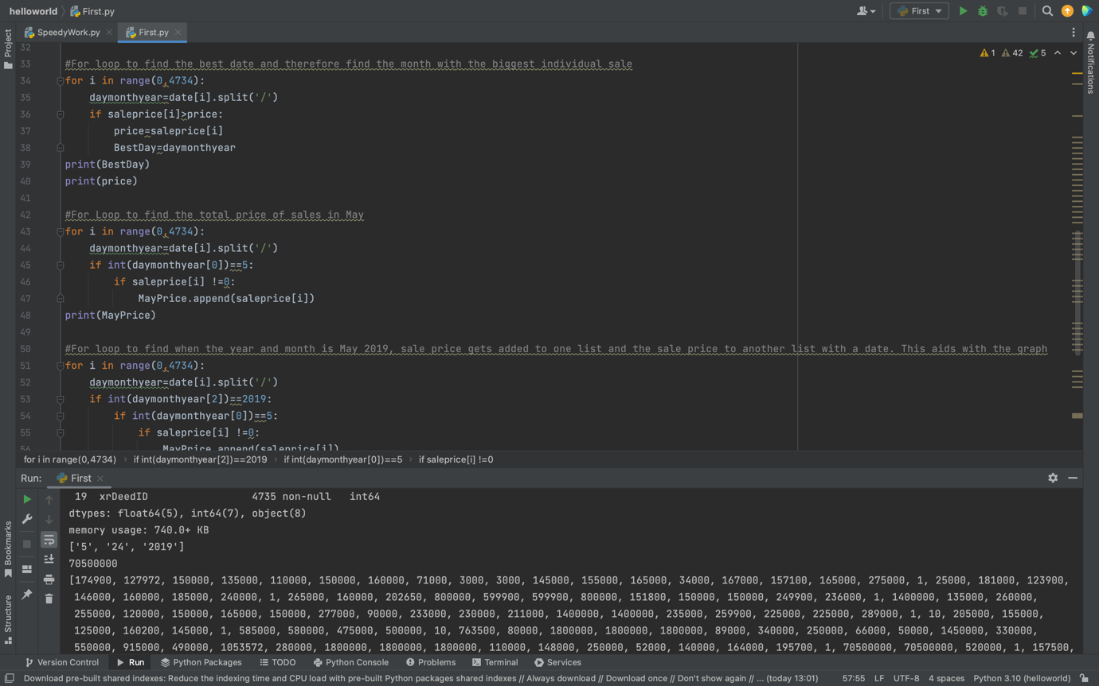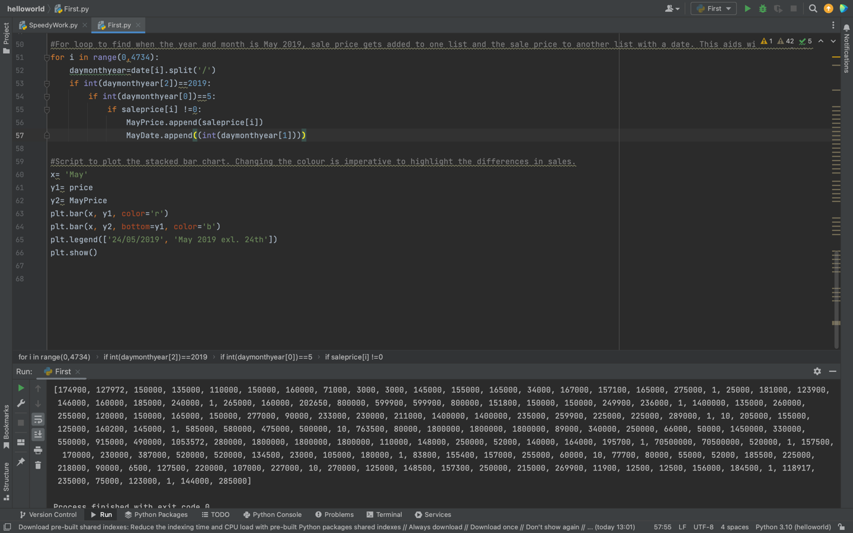

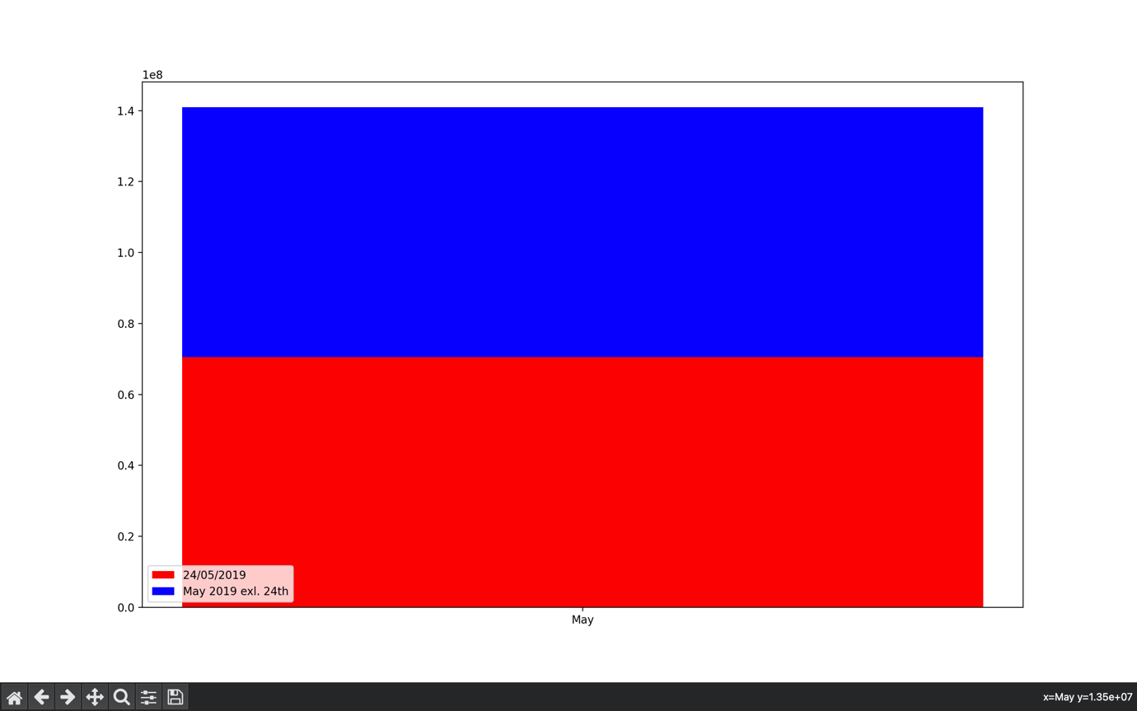

The 24th May 2019 was the date that had the largest sale in the dataset. The stacked bar chart shows how that date compares to the rest of May sales.

FurtherData

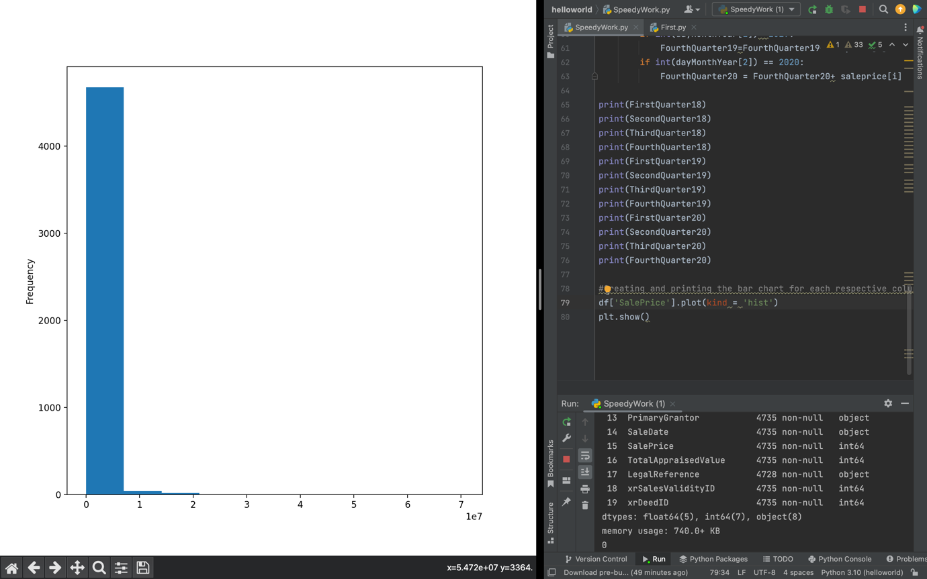

Histogram displaying the frequency of sale prices in the dataset.

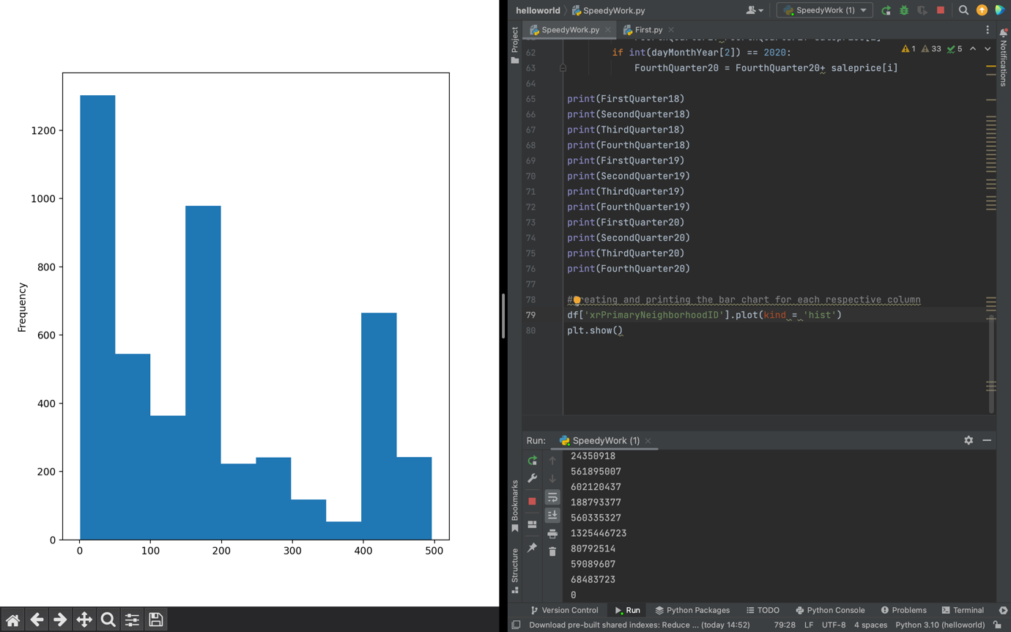

Histogram displaying the frequency of primary neighbourhoods in the data. The most common primary neighbourhood ID were the ID’s assigned below 50.

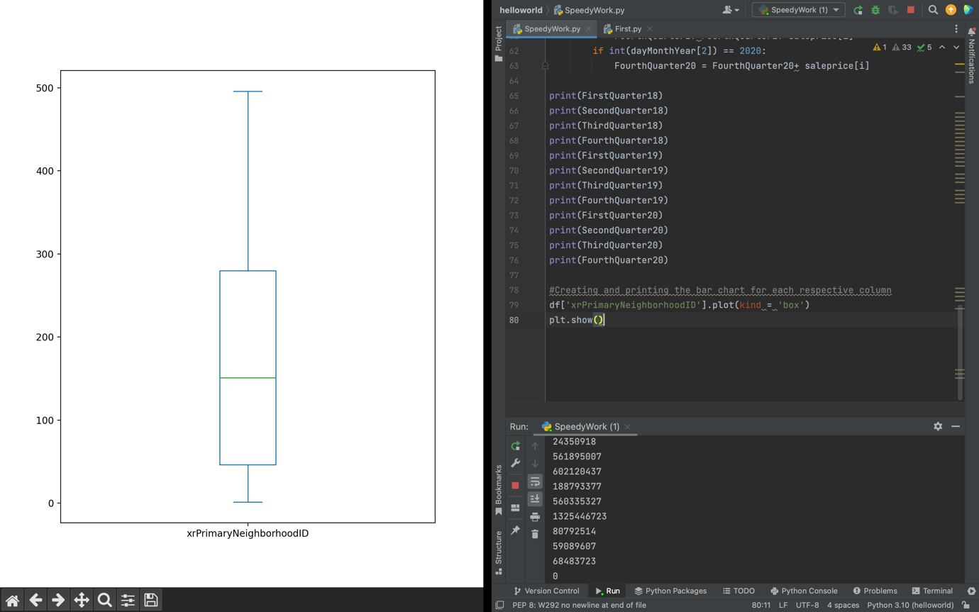

Boxplot depicting the results of the PrimaryNeighbourhoodID. Majority of the primary neighbourhoods lay between approximately 50 and 270.

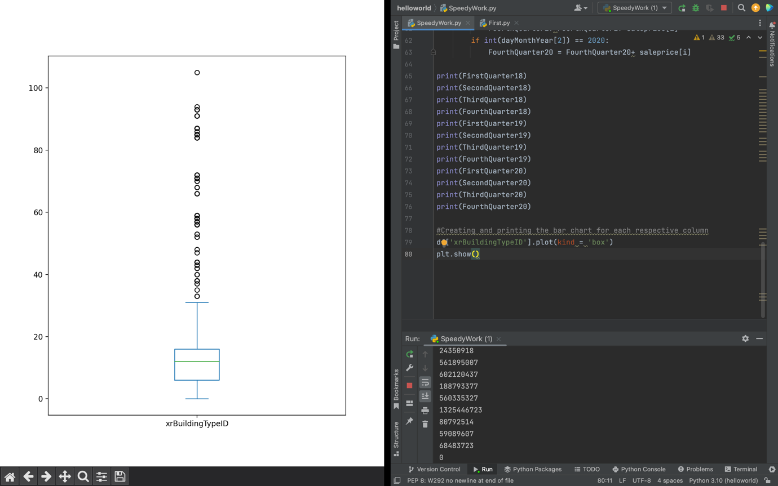

Boxplot depicting the results of the BuildingTypeID. Majority of the building types lay between approximately 10 and 18. However, there were several outliers in the boxplot above the maximum value, including an outlier at over 100.

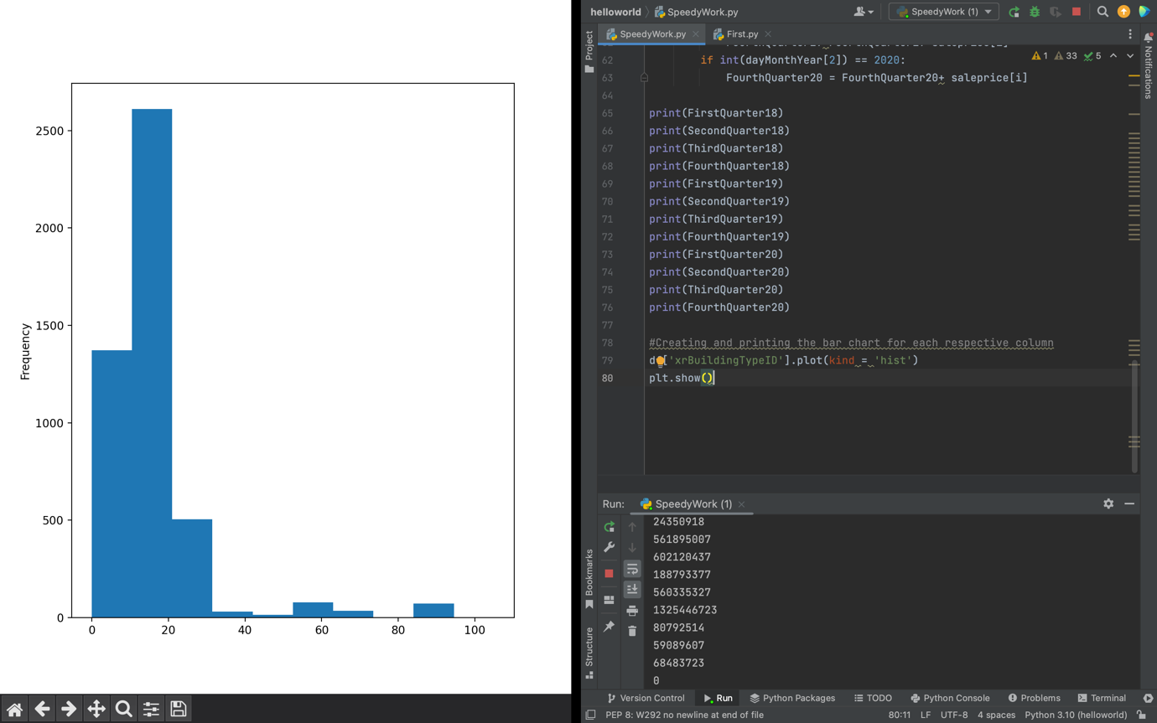

Histogram displaying the frequency of building types in the data. Buildings listed between 1 and 20 appear to be the most common.

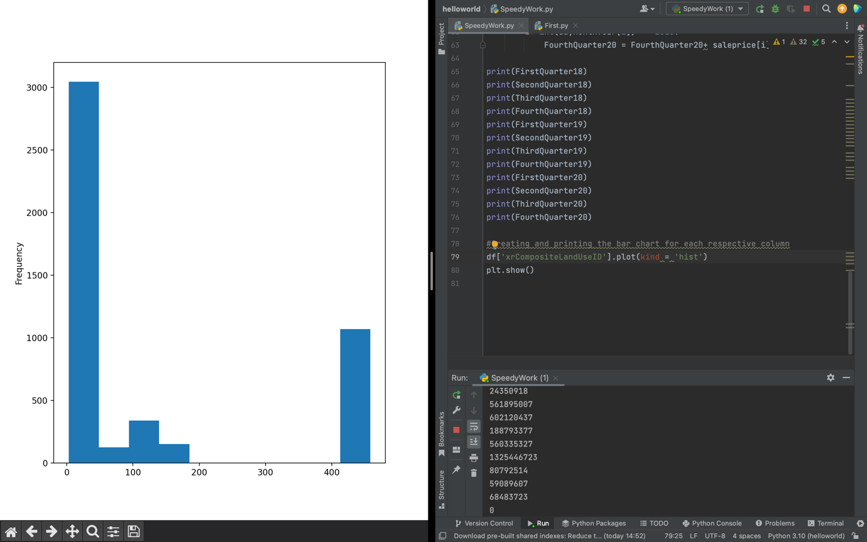

Histogram displaying the frequency of composite land used in the data. Earlier composite land ID’s have by far the most use in the data.

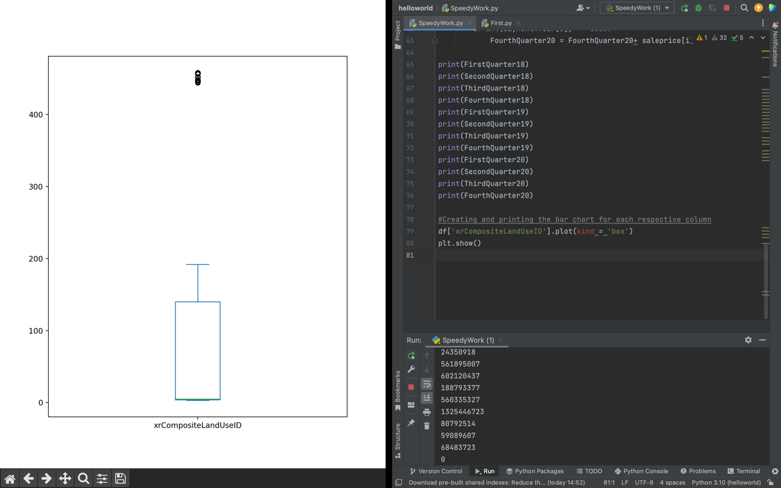

Boxplot depicting the results of the CompositeLandUseID. The median is approximately 8, with the majority of results between 4 and 150. Several outliers above 400.

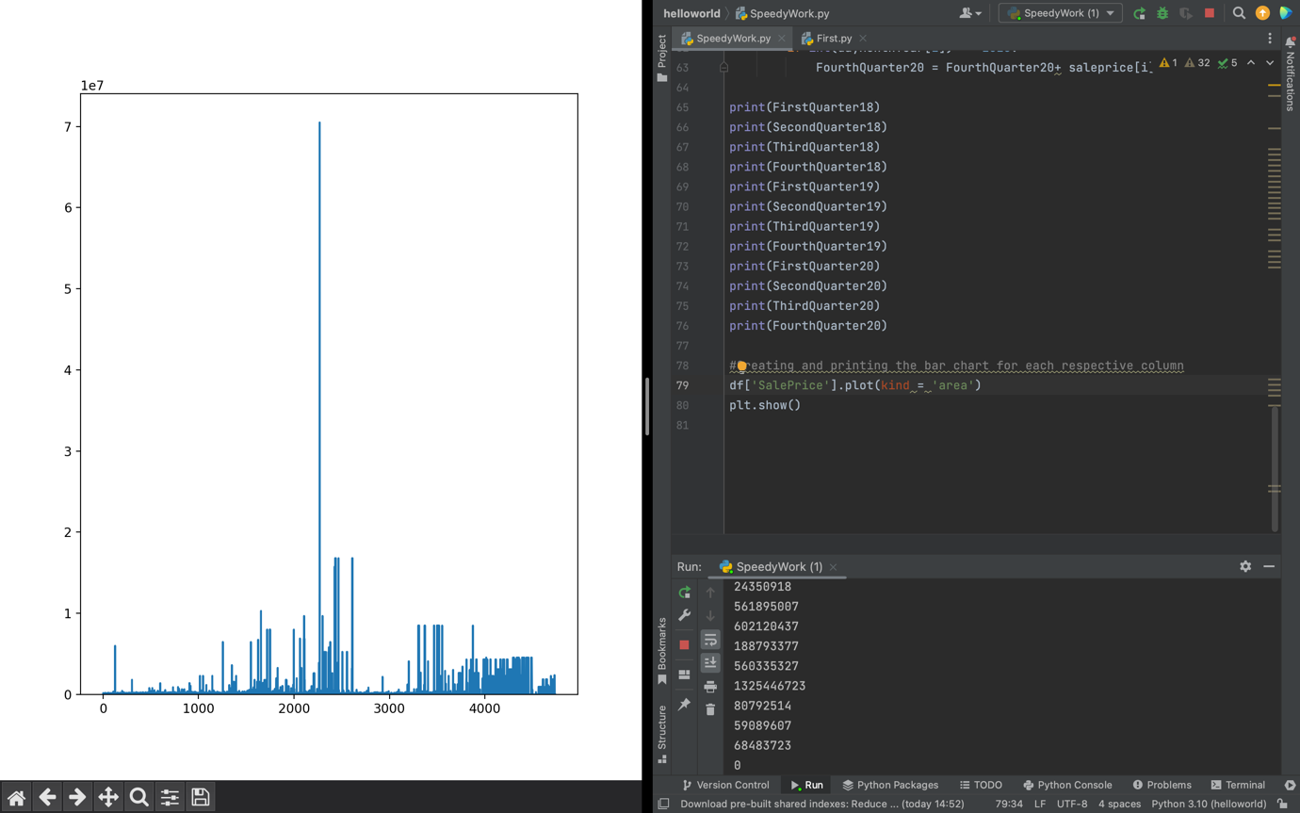

Area graph showing the variation in sale prices in the data set.

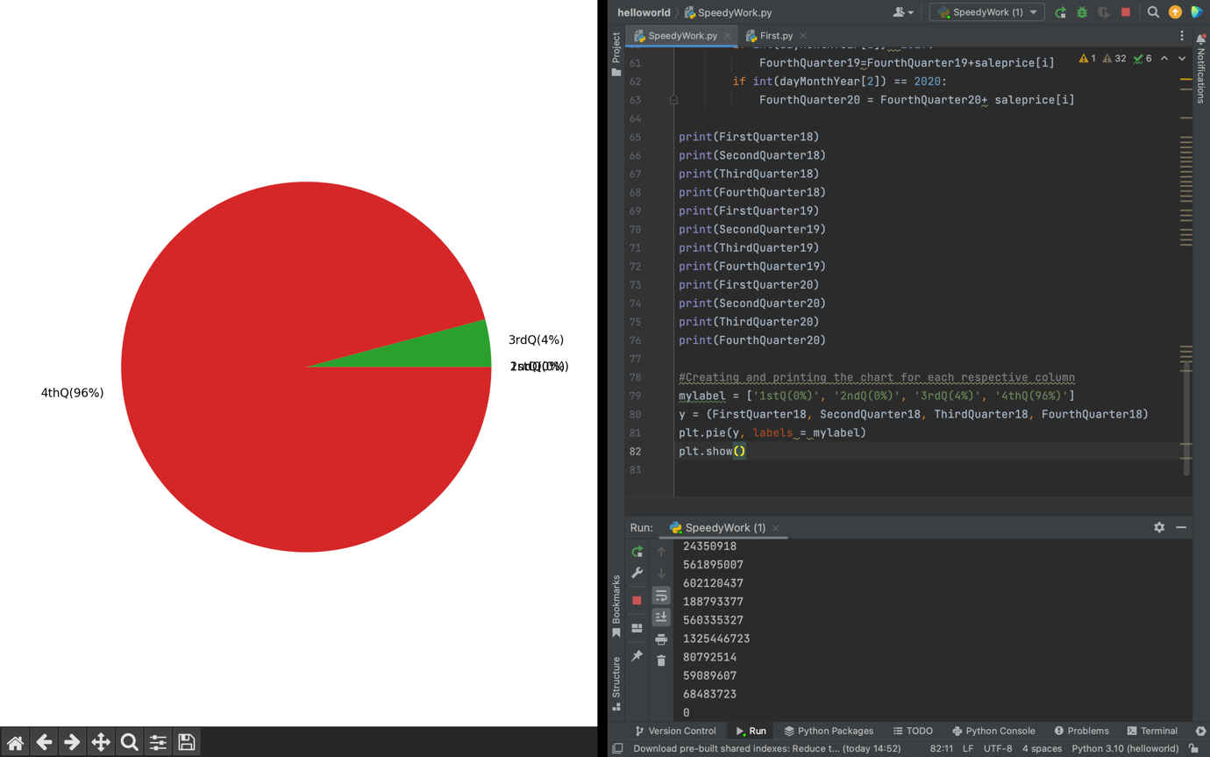

Pie chart displaying the sales for the year 2018 by quarter. Although visually different to the bar graph shown previously, the 4thQuarter still dominates 2018.

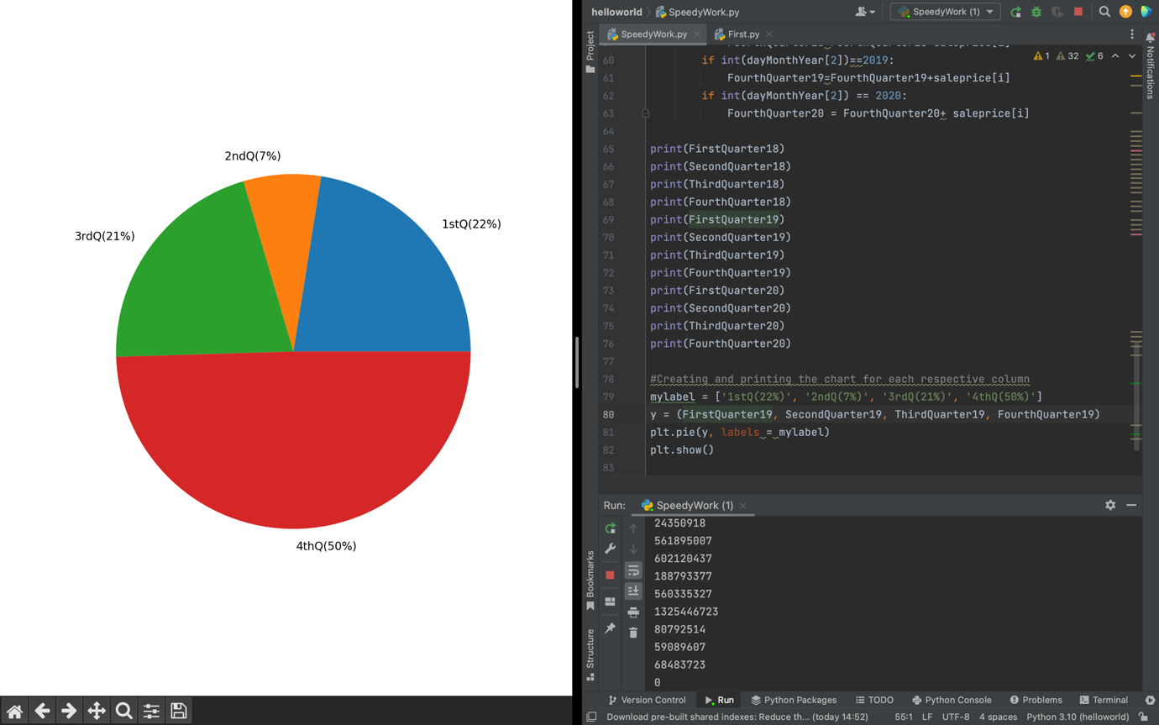

Pie chart displaying the sales for the year 2019 by quarter. 4thQuarter still dominates 2019 as it is responsible for 50% of sales in the year, however, this is the only year where each quarter had significant sales.

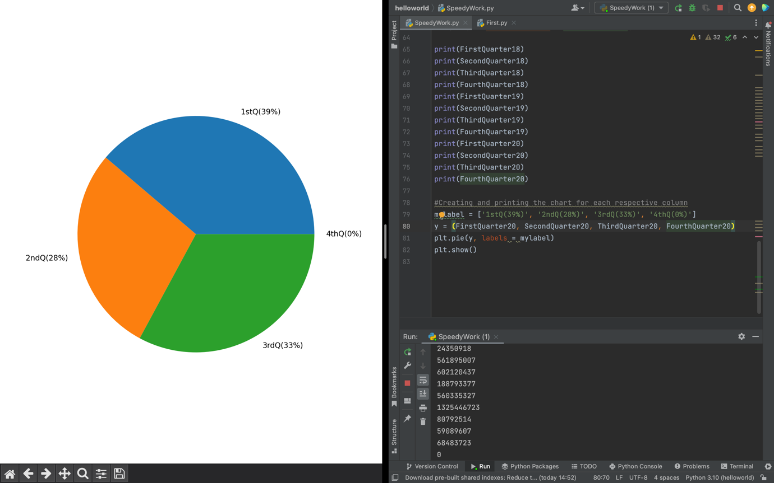

Pie chart displaying the sales for the year 2020 by quarter. Aside from the 4thQuarter, the rest of this year has sales split evenly.

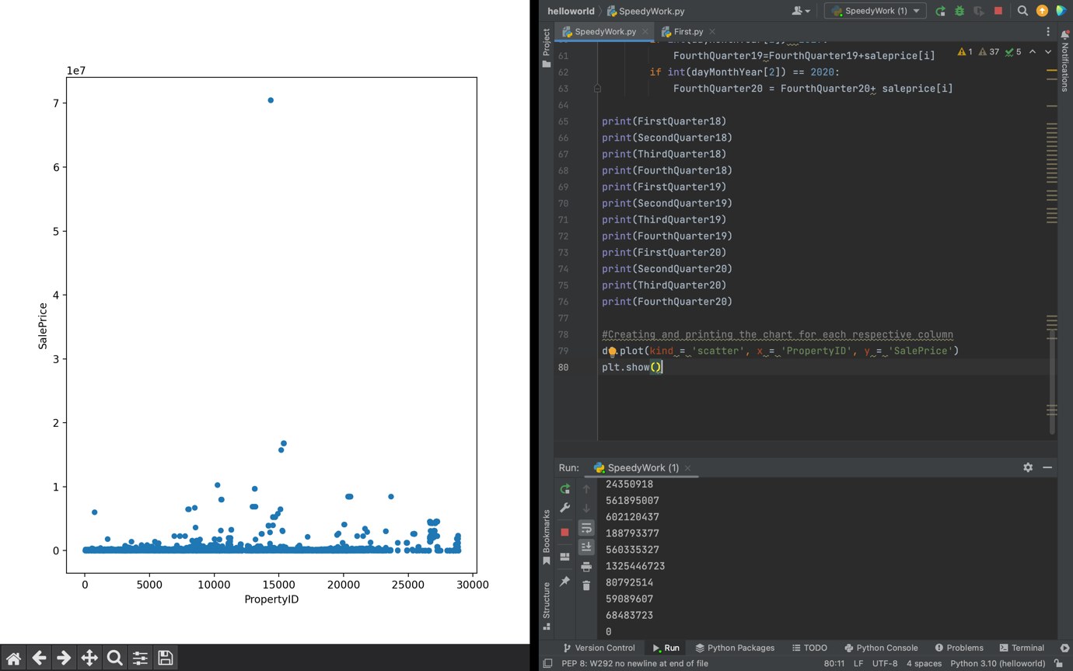

Scatter graph depicting the PropertyID against the SalePrice, with the largest sale the most outstanding in the graph.

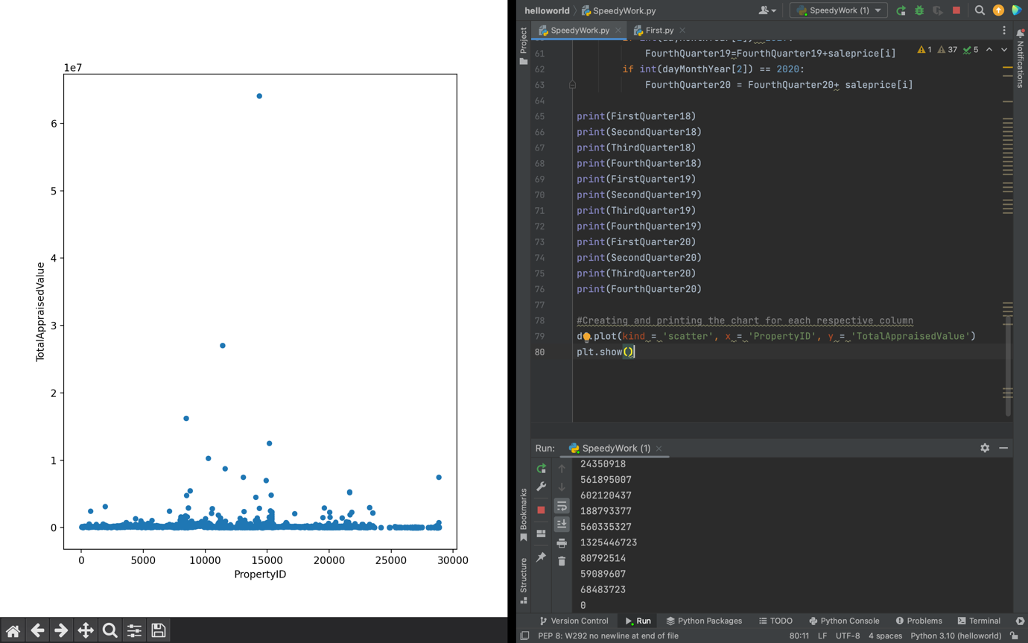

Scatter graph depicting the PropertyID against the TotalAppraisalValue, with the largest sale the most outstanding in the graph. This scatter graph strongly resembles the previous scatter graph due to this sale.

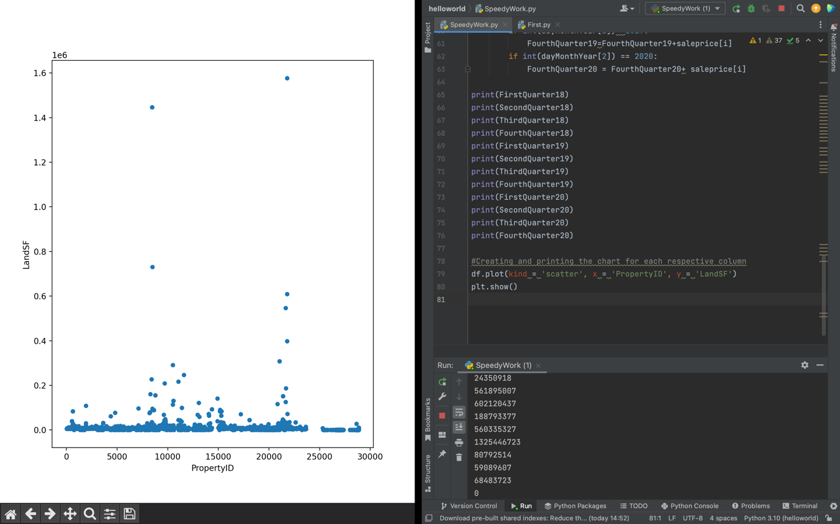

Scatter graph depicting the PropertyID against the LandSF.

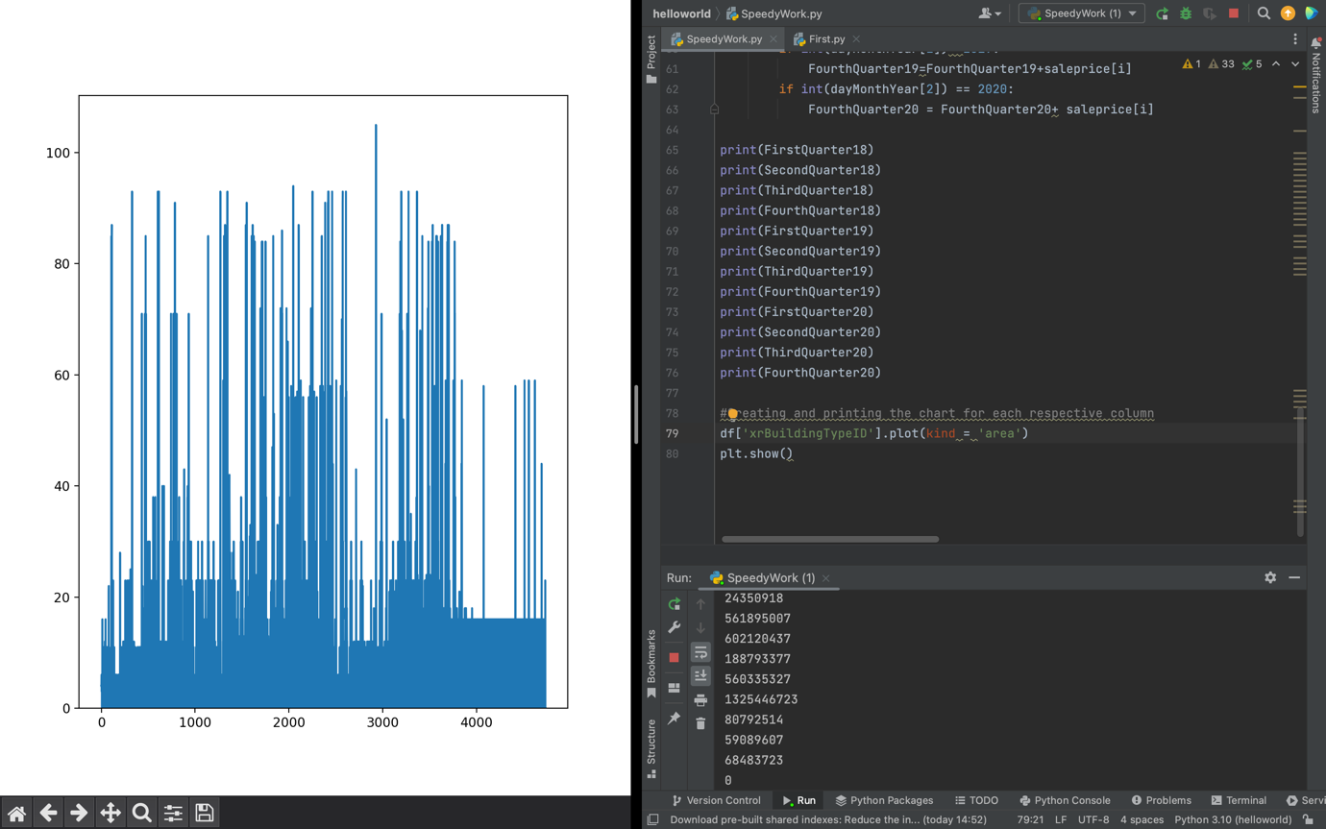

Area graph showing the variation in BuildingType in the data set.

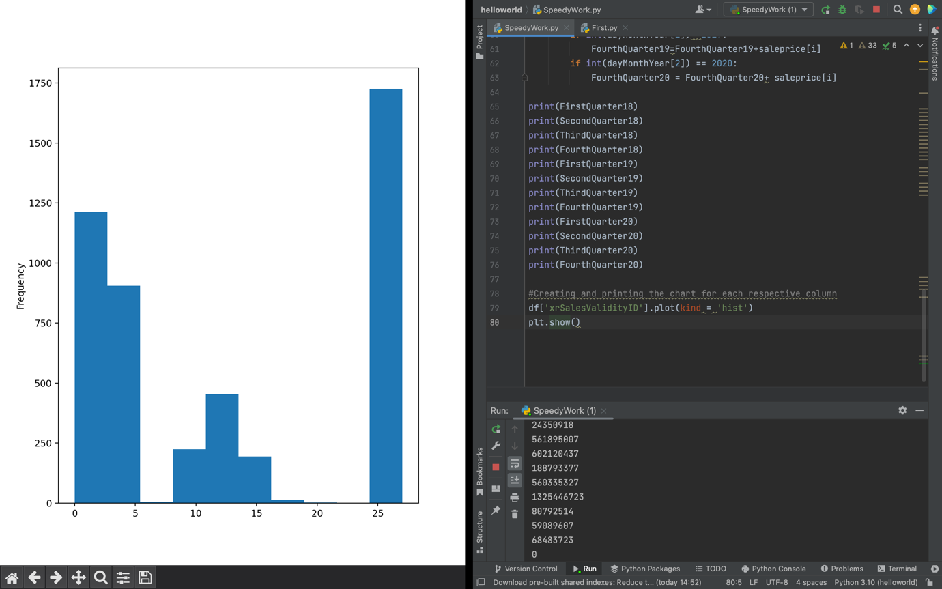

Histogram displaying the frequency of Sales validity ID.

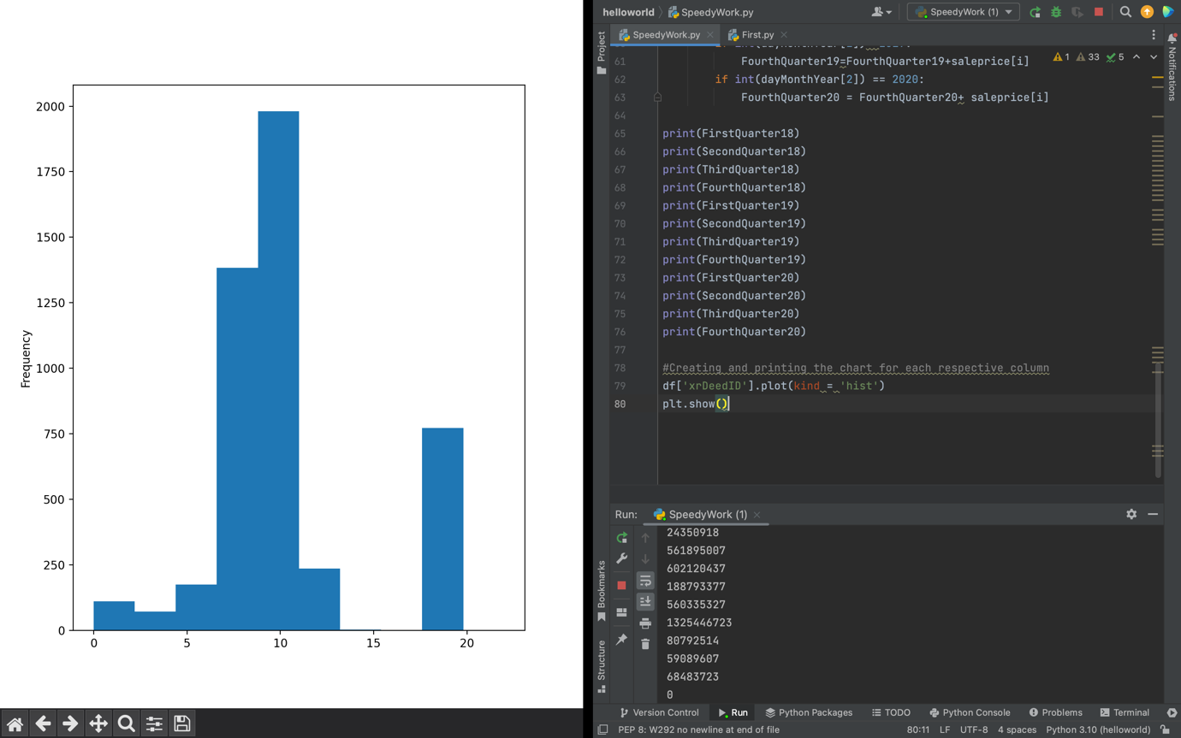

Histogram displaying the frequency of Deed ID in the data. The deed of the land tends to belong to those with an ID between 7 and 10.

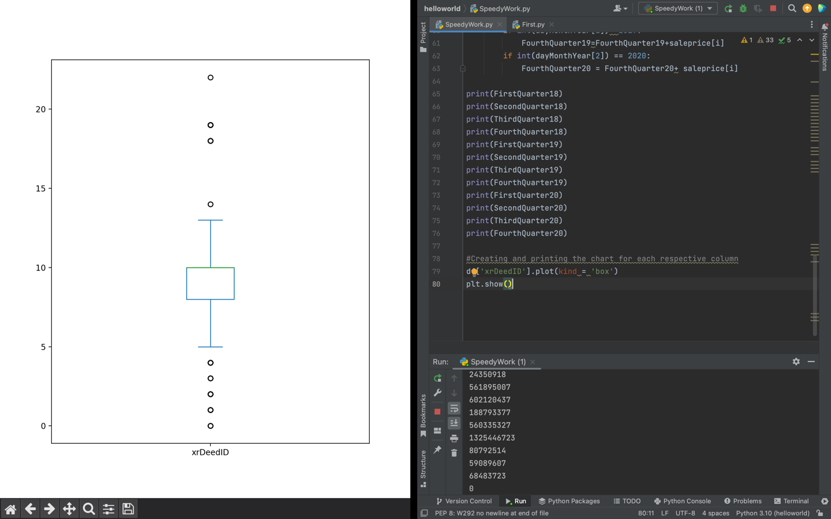

Boxplot depicting the results of the DeedID. Majority of Deeds lay between approximately 8 and 9. However, there were some owners of Deeds who can be deemed outliers due to how little of the land in the data they own.

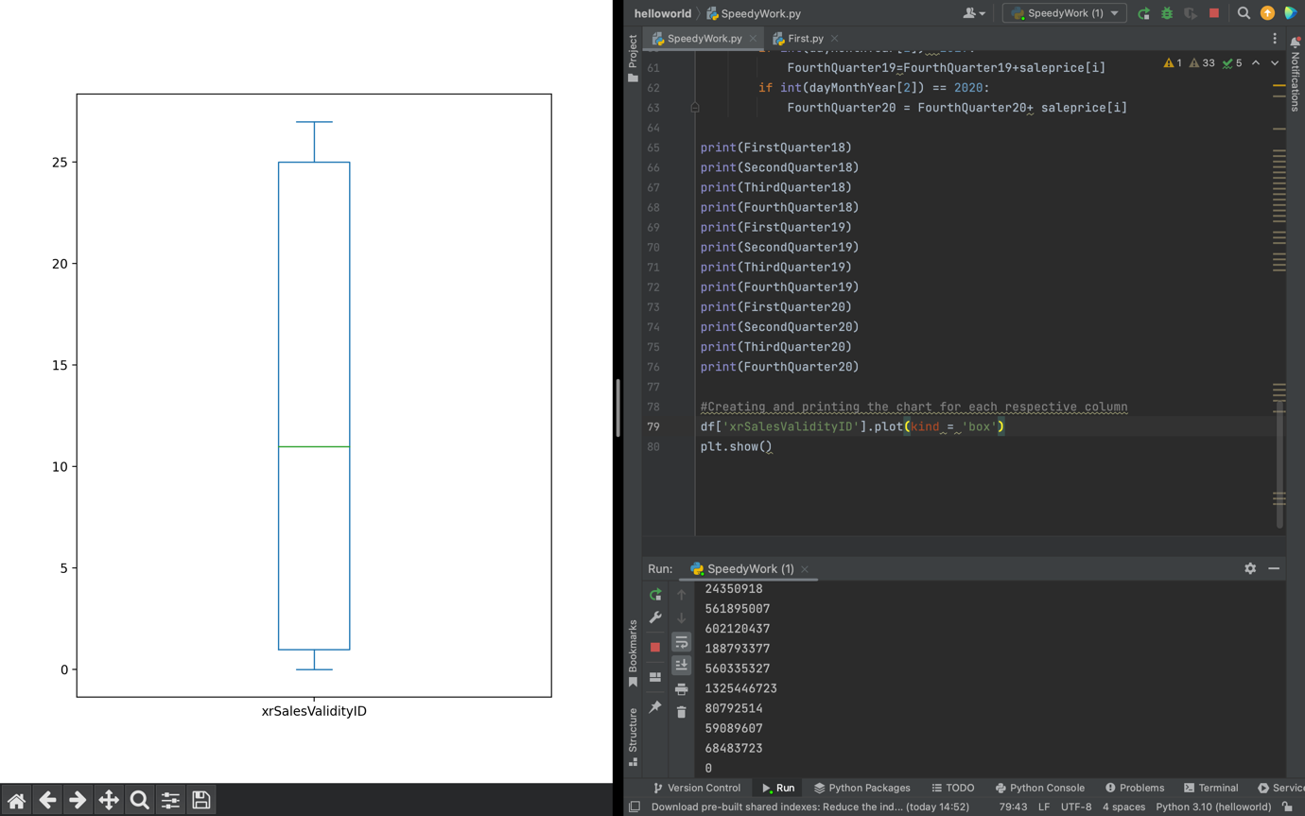

Boxplot depicting the results of the SalesValidity.

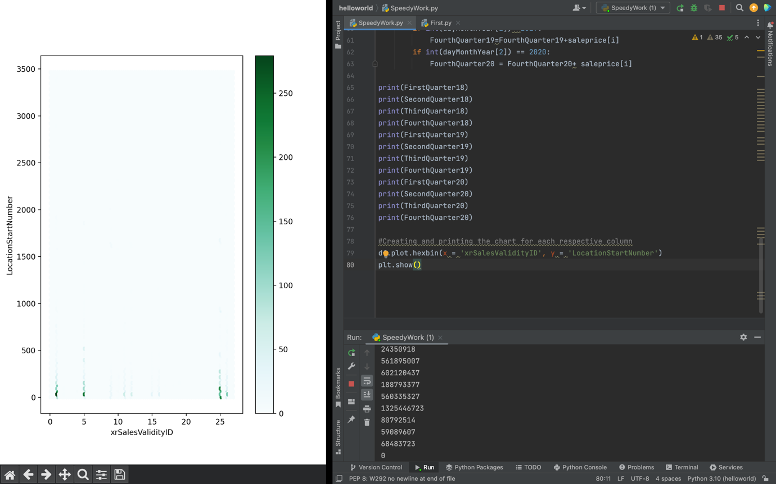A HexBin plot used to show which LocationStartNumber had to highest density of Sales using the SalesValidityID. No trends were found, with the greatest density found at 25, 5, and 1 (SalesValidity).

